**Bagging**

Bagging vs majority voting

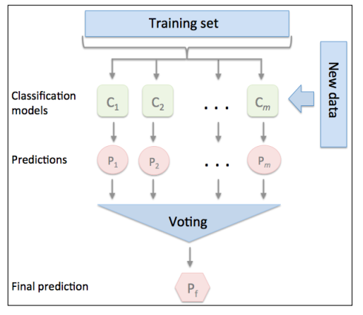

Majority voting

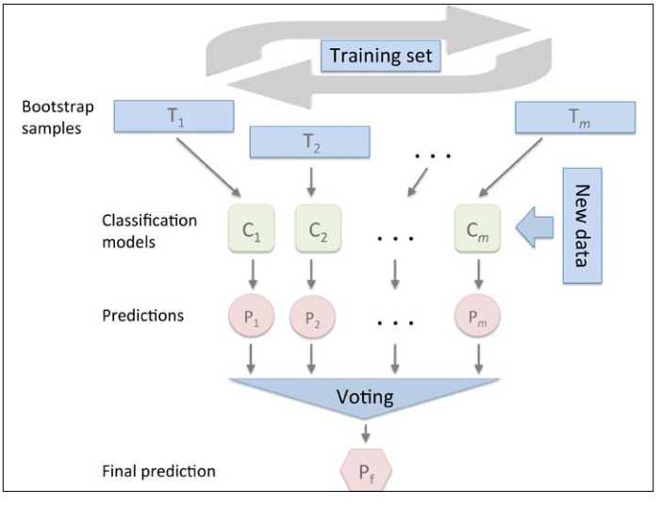

Bagging

Instead of using the same training set to fit the individual classifiers in the ensemble, we draw bootstrap samples (random samples with replacement) from the initial training set , which is why bagging is also known as bootstrap aggregating.

Random forests are a special case of bagging where we also use random feature subsets to fit the individual decision trees.

Reference:

1. Python machine learning